**SQL JOIN Practice Questions**

Assume you have the following two tables:

**Employees**

| **emp_id** | **name** | **department_id** | **salary** |
| --- | --- | --- | --- |
| 1 | Alice | 101 | 5000 |
| 2 | Bob | 102 | 6000 |
| 3  4 | Charlie Dave | NULL  101 | 5500  7000 |

**Departments**

| **department_id** | **department_name** |
| --- | --- |
| 101 | HR |
| 102 | IT |
| 103 | Marketing |

**Basic JOINs**

1. Write a query to get all employees along with their department names. 2. List the names of employees who **do not belong** to any department. 3. List all departments and the names of employees in them (if any).

**INNER, LEFT, RIGHT, FULL JOINs**

4. Use an **INNER JOIN** to find employees who are assigned to a department.

5. Use a **LEFT JOIN** to list all employees and their department names (even if department is NULL).

6. Use a **RIGHT JOIN** to list all departments and employees (if any).

7. Use a **FULL OUTER JOIN** to show all employees and all departments, matching where possible.

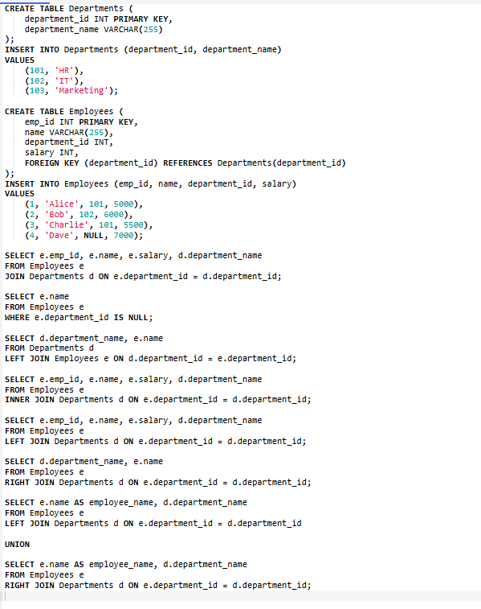

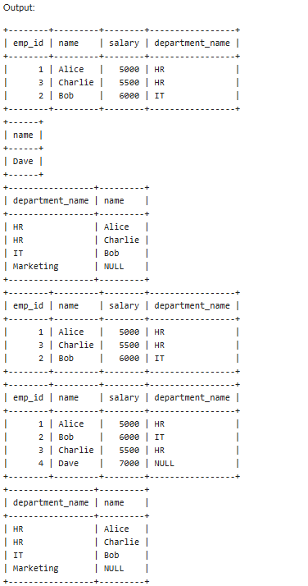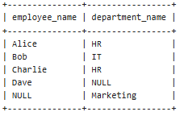

**JOIN with Conditions**

8. Write a query to list employees who earn more than any other employee in their department.

9. List all departments where **no employees** are assigned.

10. For each department, show the number of employees and the average salary.

**SQL Trigger Practice Questions**

Assume you have a table:

**Orders**

| **order_id** | **customer_name** | **amount** | **status** |
| --- | --- | --- | --- |
| 1 | John Doe | 200 | pending |
| 2 | Alice Smith | 350 | shipped |

And a log table:

**Order_Log**

| **log_id** | **order_id** | **operation** | **changed_at** |
| --- | --- | --- | --- |
|  |  |  |  |

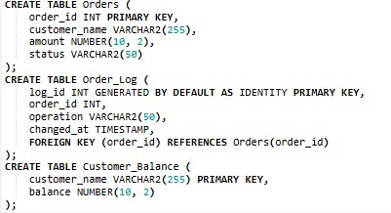

**Trigger Practice**

1. Create a trigger that inserts a row into Order_Log **after an order is inserted** into Orders.

2. Create a trigger that logs an update to the Orders table whenever the status changes.

3. Write a trigger that prevents inserting an order with a negative amount.

4. Write a trigger that automatically sets the status to "pending" if no status is provided during insert.

5. Create a trigger that updates another table Customer_Balance whenever an order is placed.

